Noer akhmad ramadhani/XII RPL-2

1.pertama aktivkan composer lalu uat new project di apk visual studio code

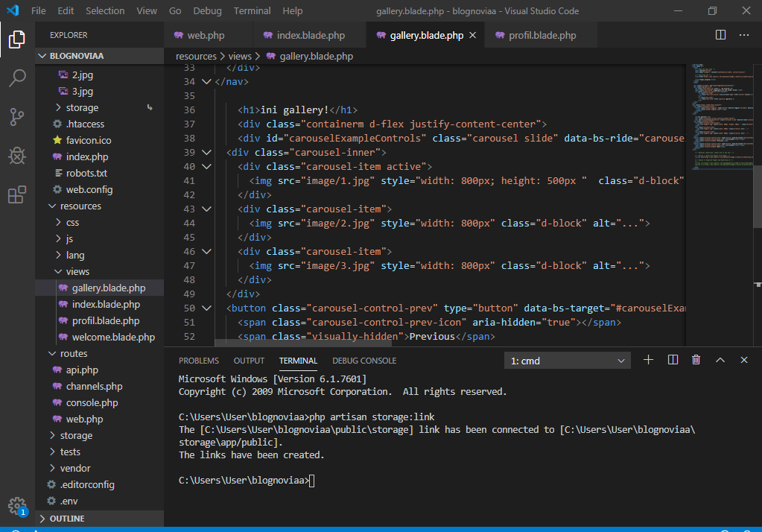

2.

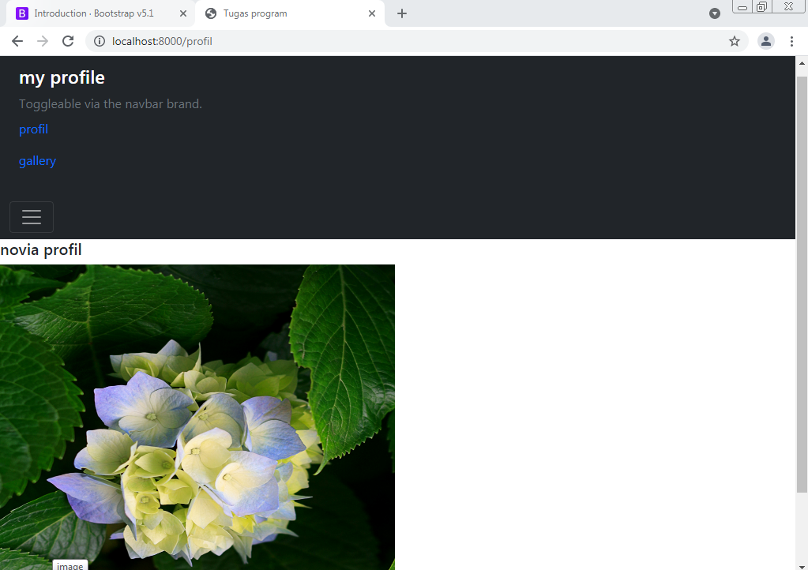

3.

